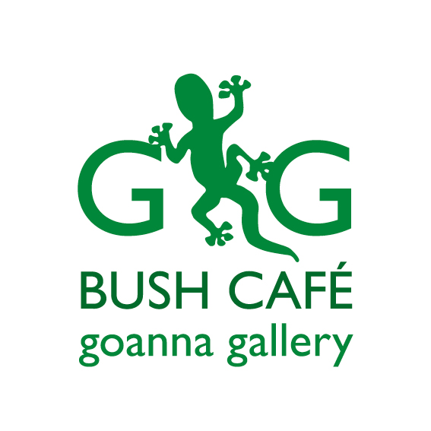

**MOTHER’S DAY LUNCH**

*Set Menu*

Two Course $45 per person

Three Course $55 per person

ENTRÉE

Wild mushroom & taleggio arancini with pesto, mixed leaf salad V

Soup of the day, grilled turkish bread GF*

Farmhouse Charcuterie board, house made chutney, grilled YWF bread DF/GF*

***Frizzante $10 Gls $45 Btl Mongrel Creek SSB $7 Gls $28 Btl***

MAIN

Fremantle grilled swordfish loin, fried spiced belly croquette with quinoa, cauliflower, olives, capers, radish, salsa verde V/DF/GF*

***Blind Corner SB $9 Gls $36 Btl***

Pan-fried potato gnocchi, Jerusalem artichoke puree, braised field mushroom, beurre noisette with crisp sage, walnuts, Parmesan V

***Flametree Chardonnay $9 Gls $38 Btl***

Confit smoked beef brisket, roasted shallot, cocotte potatoes, green beans, and béarnaise sauce

***East of Alice Shiraz/Graciano blend $8 Gls $32 Btl***

Taste Plate for 2 – see daily boards

DESSERT

Choose from our selection of homemade cakes, served with coffee or tea

** Wine Pairing listed below each dish **